Tristan Izlar

CGS1831

# Angry Nerd Café Project Plan

**Client Name**

* **Angry Nerd Cafe**

**Website Descriptions**

* A café inclusive of all things nerdy, where all are welcome!

**Client Expectations**

* Clear indication of the culture/vibe that the café is trying to provide, which makes them different from the competition.
* Visualizations of the delicious food/drink products provided at the establishment.
* Logical design that clearly provides navigation, contact information, and other crucial information, such as hours, location, social media links, etc.

**Target Audience**

* The café is for anyone who has a desire to feel nostalgically nerdy and needs somewhere to focus with a cup of coffee. Would most likely attract teens/young adults but is a space for everyone. People who like things like video games, comics, cartoons, etc, would especially enjoy this place.

**Competititors**

* Competitor 1 is <https://intermezzo.co/>
  + Strength 1 – Navigation & Header are clearly along the top of the page.
  + Strength 2 – The chosen colors work beautifully together.
  + Weakness 1 – Background Image quality becomes pixelated on larger screens. The background images should have been fixed to a certain width.
  + Weakness 2 – The menu is built into the home page and only seen once you scroll down. This could have been its own navigation item.
* Competitor 2 is <https://www.banyancoffee.com/>
  + Strength 1 – The navigation bar comes with the user as they scroll, and each navigation item scrolls the user to a certain point down the page. The nav bar also contains all crutial business information.
  + Strength 2 – Design is clean and consise. I am not struggling to find any information or overwhelmmed by it.
  + Weakness 1 – The drink menu does not have enough contrast between the text and the image behind it. For users with poor eye sight this could be an issue.
  + Weakness 2 – The tab “Restaurant” contains the contact information. This tab seems like it combine an about section and a contact section, which doesn’t really do any favors to the user.
* Competitor 3 - <https://blackcrowcoffee.square.site/>
  + Strength 1 – Menu is basically front and center. The design allows the user to click an item and get right to ordering it.
  + Strength 2 – Overall the page isn’t overwhelming or cluttered with information. A user can easily scan it to find most of the important information.
  + Weakness 1 – No contact information aside from an address. This could mean the loss of a sale if someone has an inquiry about the products.
  + Weakness 2 – No company information, hours, or image galleries available for the user. This website really is only good for ordering products, and doesn’t show off what makes Black Crow special at all.

**Written Summary**

* Overall, the competition of the area has fairly well-done websites that do well to showcase their culture. To be truly unique in a web design capacity, having all encompassing information yet retaining a minimalist appearance will be important. The competition all had very clean websites but sacrificed important information in some cases, or even navigation elements. In addition to that, providing a clear visual for all users and their devices will be important. Testing on different browsers and devices would be the most effective way to ensure we do not run into scaling issues. Hand in hand with effective visualization will be the usage of images to show off what the Angry Nerd Café produces. Speaking to people’s appetites is important when drawing them into an establishment that sells food & beverages.

**Site Map**

**Linear Organization – As they scroll they hit each section. The navigation bar is locked to the top of the screen no matter what page they are on.**

**Wire frame Page Layout**

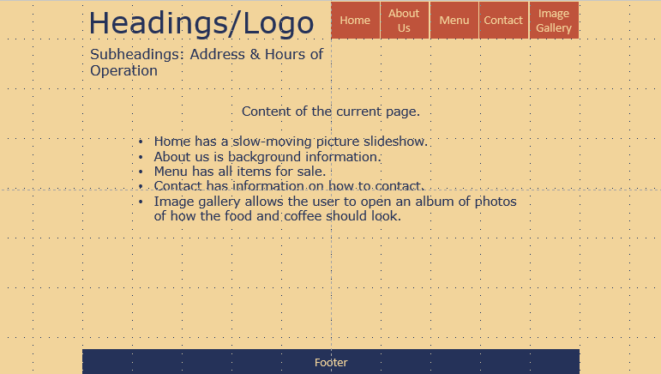

**Color Scheme**

* [**https://color.adobe.com/search?q=retro**](https://color.adobe.com/search?q=retro)
  + **Retro theme**
* This theme will be able to provide good contrast for the text on a lighter background. The retro theme can fit with an arcade vibe but also is not so obnoxious it scares off potential visitors.

**Page Layout**

* A liquid layout style would be ideal to ensure the clients website fits on any screen size and doesn’t become disorienting. It will also prevent the pictures from becomes pixelated.

**Font**

* Heading – Verdana – about 48 pt. in size or h1 – no weight.
* Subheadings - Verdana – about 24 pt. in size or h3 – no weight.
* Main content/Navigation Bar – Verdana - about 14 pt. in size to prevent eye strain – no weight.
* Footer – Verdana - 9 pt. in size – Italics.
* According to the text Verdana is one of the easier fonts to view on a computer screen. I also opted to use fonts that may be bigger than I like, to help users view the content without eye strain. This could be changed if it is not appropriate when the site is made.